**Final project -Batch Q3**

**Questions:**

**1.Give the Country code from the order id column**

**Query:**

**use projectq3**

**select * from store2**

**select substring(`Order ID` ,1,2) from store2**

**Answer:**

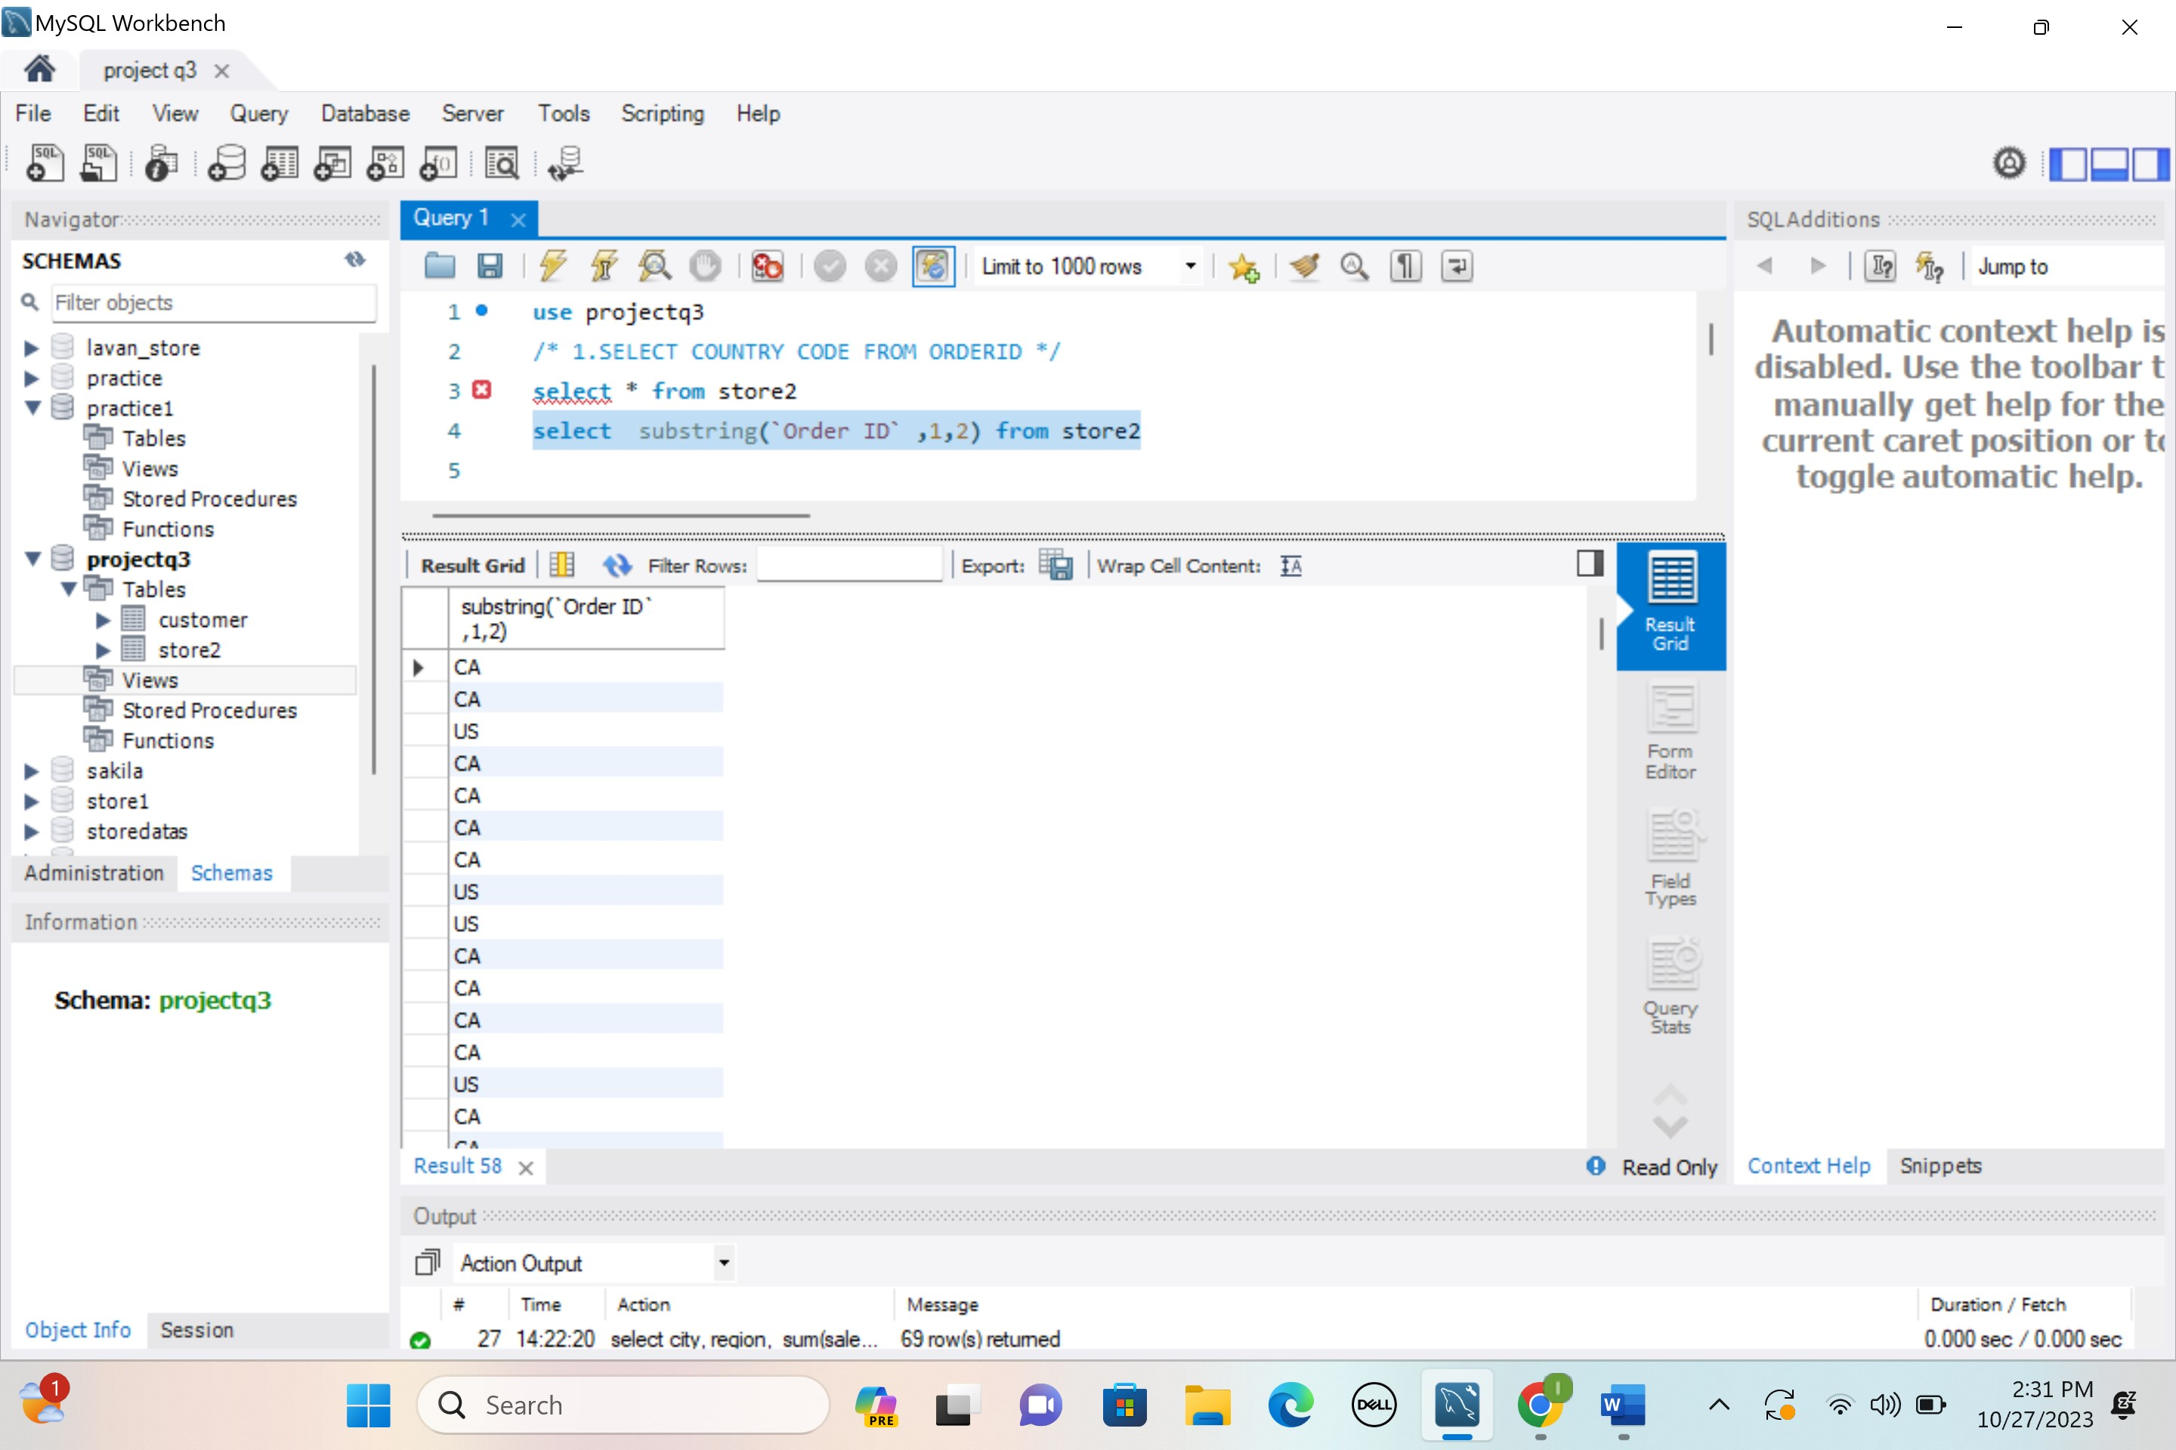

**2.Get the top 5 profit from sales for each city wise**

**Query:**

select * from

(select city,sales,profit,

row_number() over( partition by city order by profit desc )

topvalues from store2 ) topval

where topval.topvalues < 6 ;

Output:

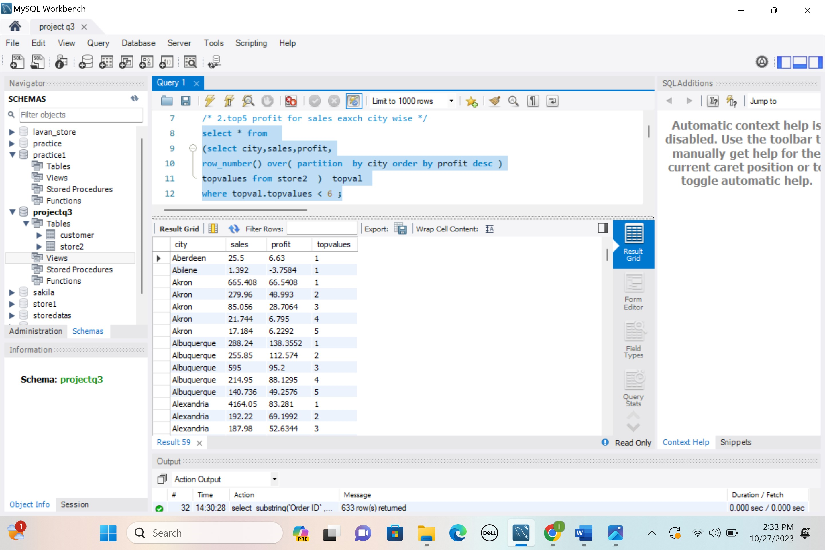

**3.Extract the maximum values using row number function**

**Query:**

select city,profit from

(select city,sales,profit,

row_number() over( partition by city order by profit desc )

rowmax from store2 ) rowmaxvalue

where rowmaxvalue.rowmax = 1 ;

Output:

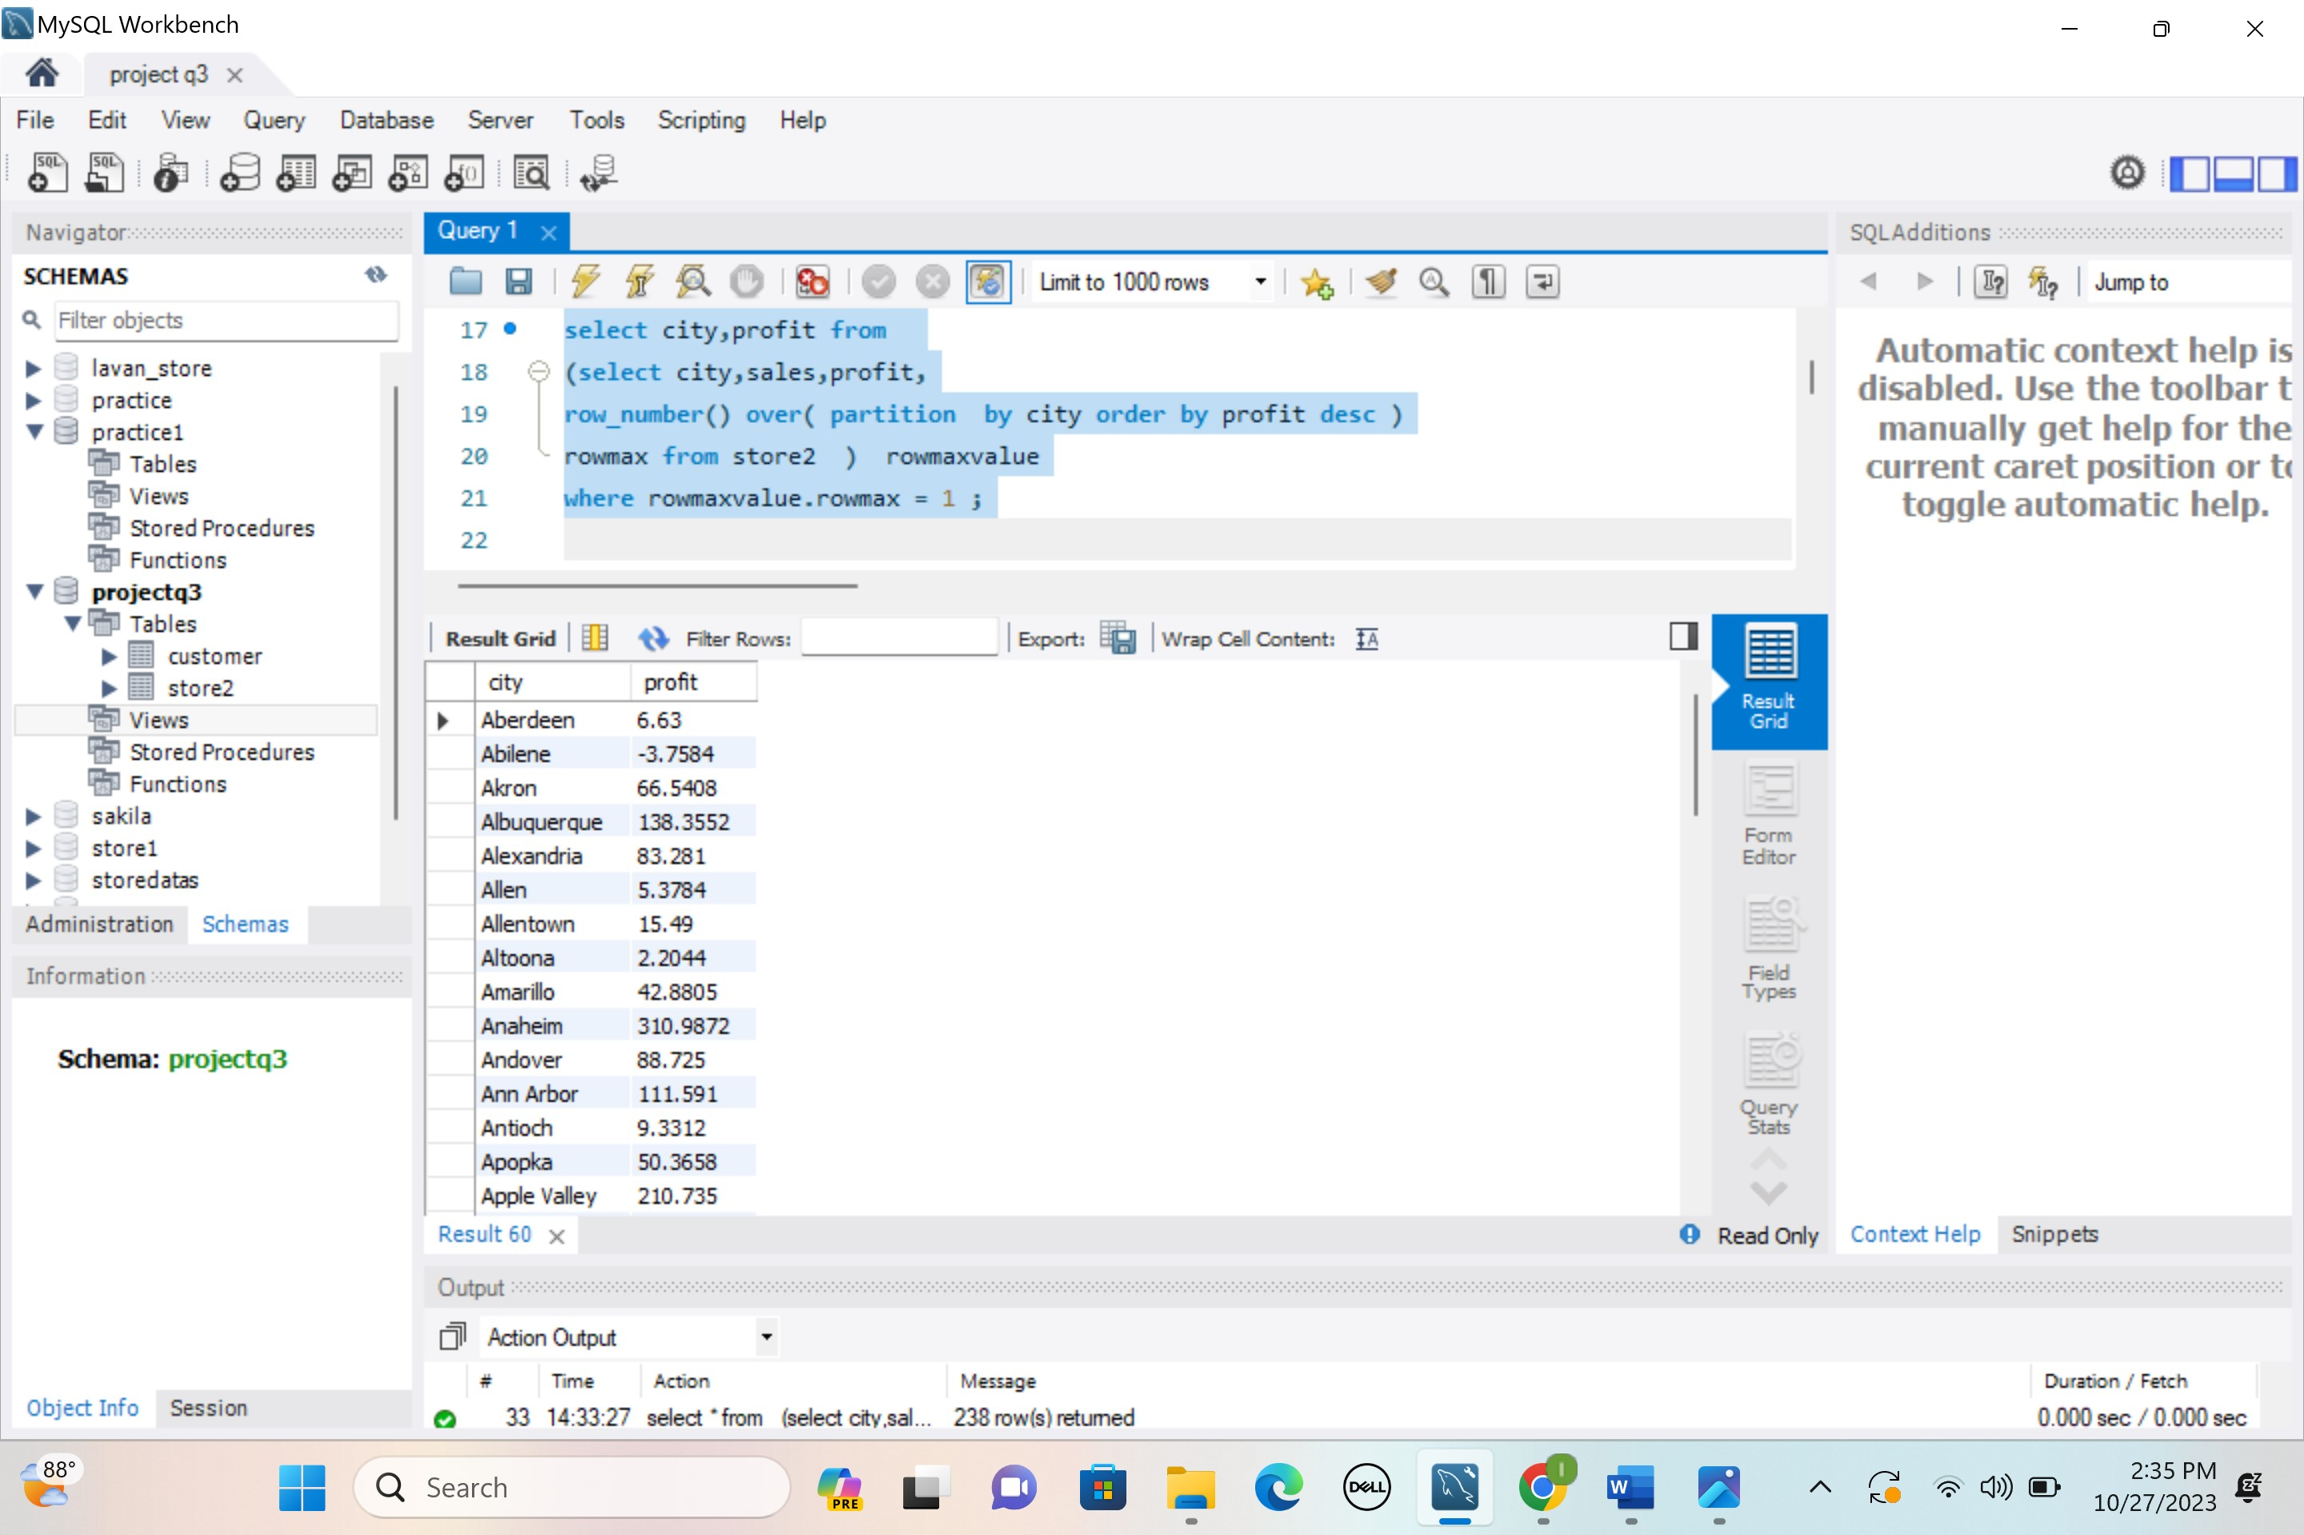

**4.remove duplicates from city , state**

**Query:**

/* 4.to remove duplicates from sales and city as separate query*/

select distinct (state) from store2

select distinct(city) from store2

/* 4. removing duplicates in a single query */

select distinct least( state, city) as col1 , greatest(state, city) as col2 from store2

Output

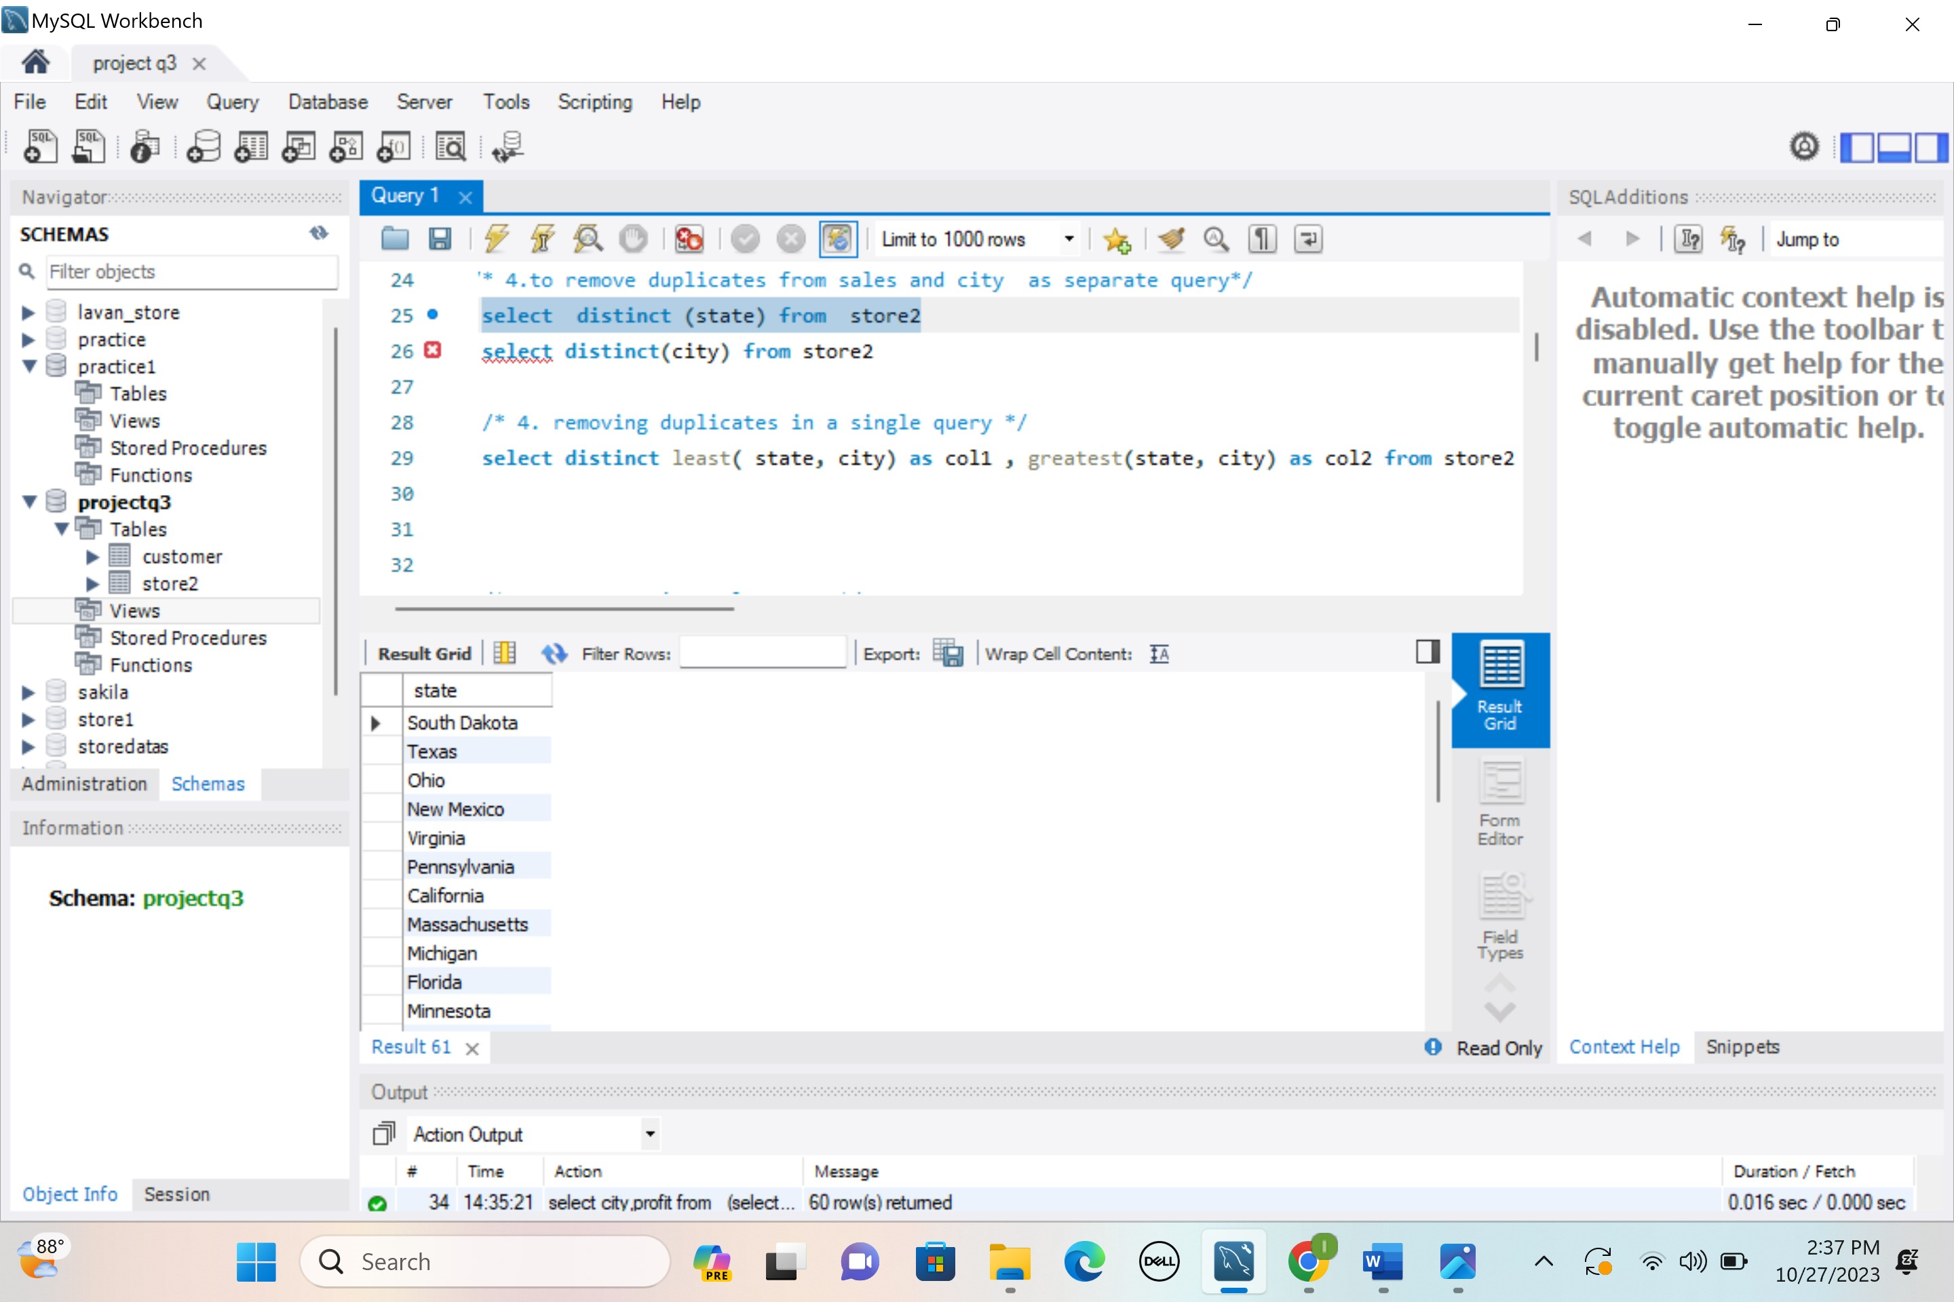

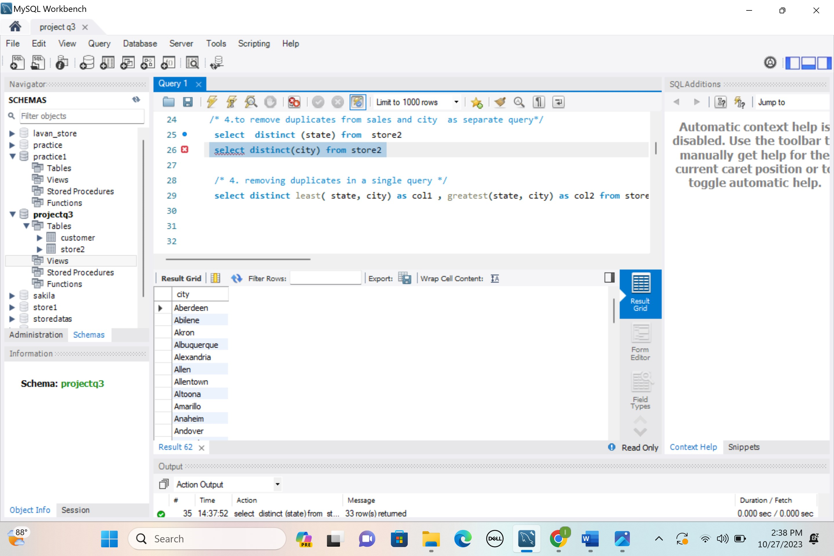

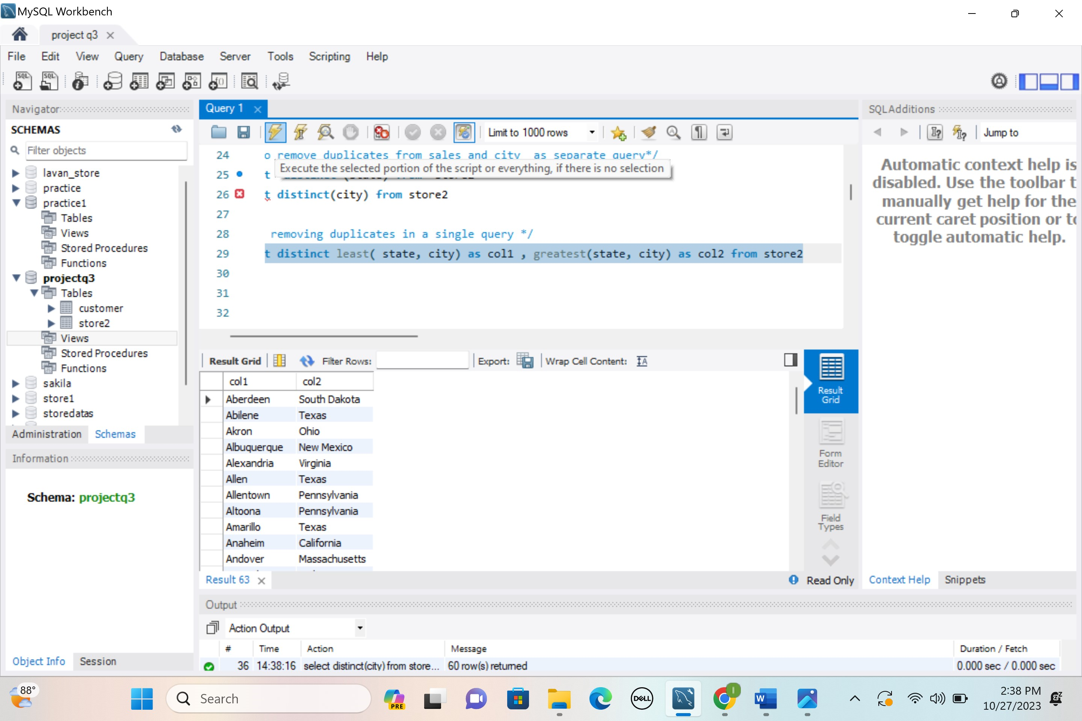

**5.Segment wise sales which is greater than 500**

**Query:**

select segment, sales from

(select segment, sales,

row_number() over( partition by segment order by sales desc )

segmentwise from store2 ) segmenttab

where segmenttab.sales > 500 ;

Output:

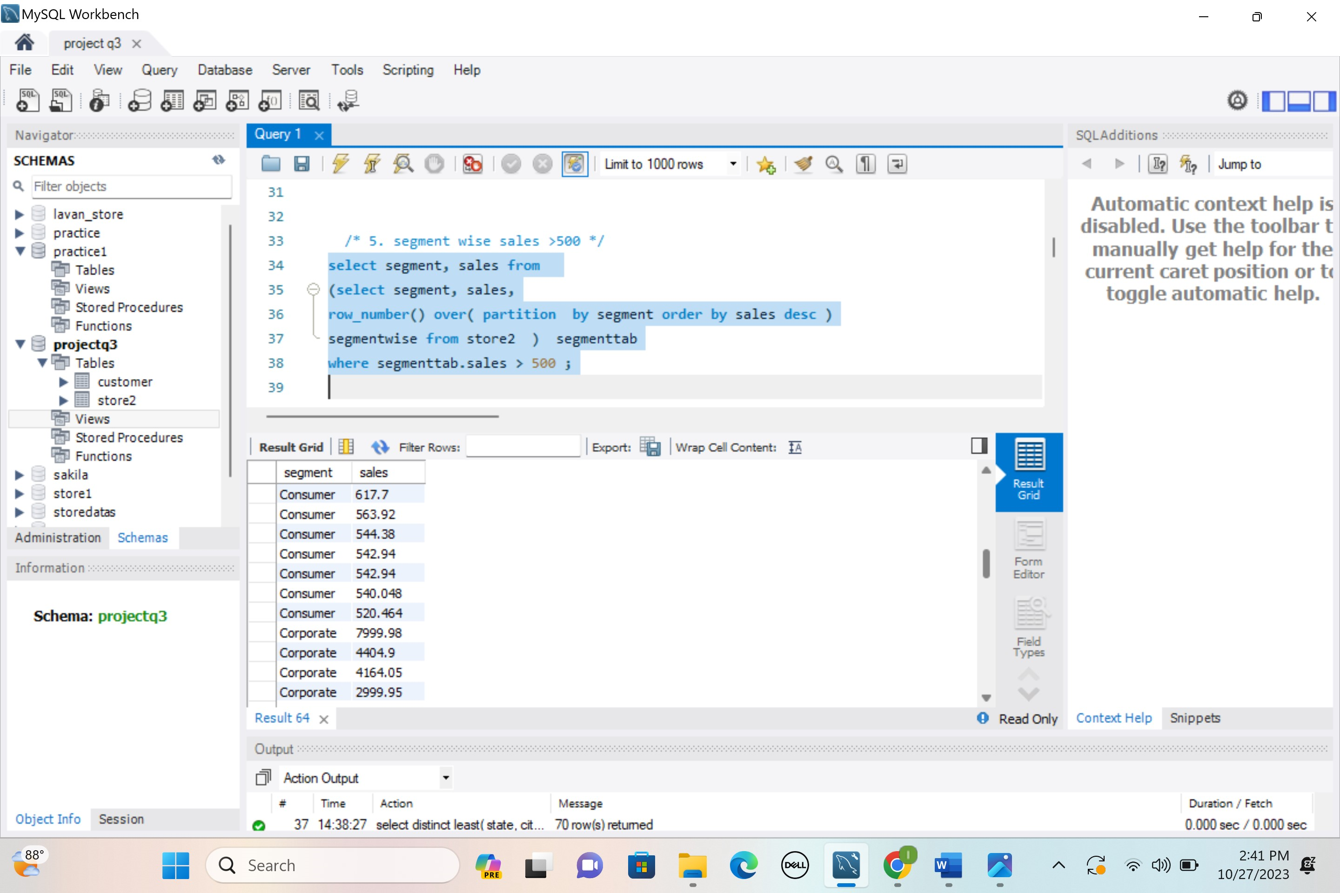

**6.Category Sales 0 - 100 as low , 101 - 500 medium , 500 - 2000 as high , > 2000  as best**

**Query:**

select sales ,

case

when sales <= 100 then " LOW"

when sales >100 && sales <=500 then "MEDIUM"

when sales > 500 && sales < 2000 then "HIGH"

else " BEST"

end as salerating

from store2;

output:

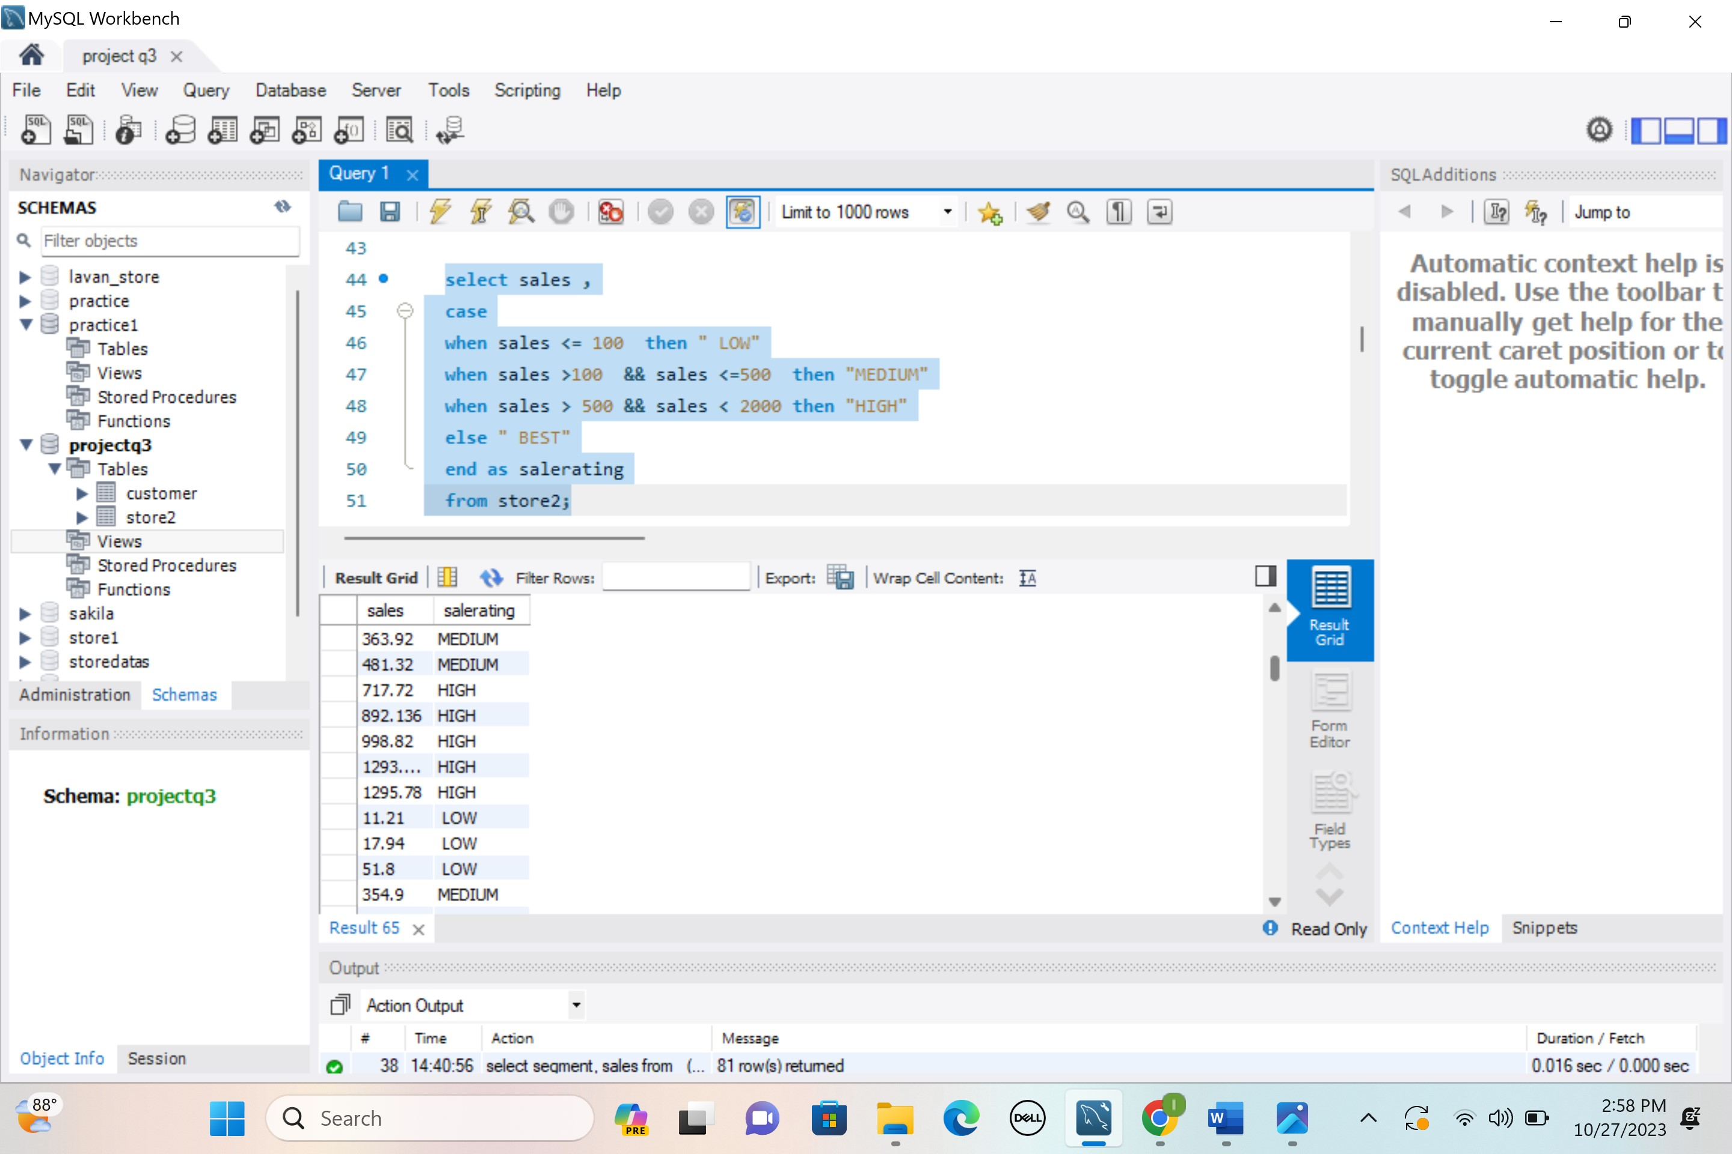

**7.city , region wise sum of sales , profits , count of sales & profits**

**Query:**

select city, region, sum(sales ) as Sumofsales , sum( profit) as sumofprofit ,

count(sales) as countofsales , count(profit) as countofprofit

from store2

group by city, region

Output:

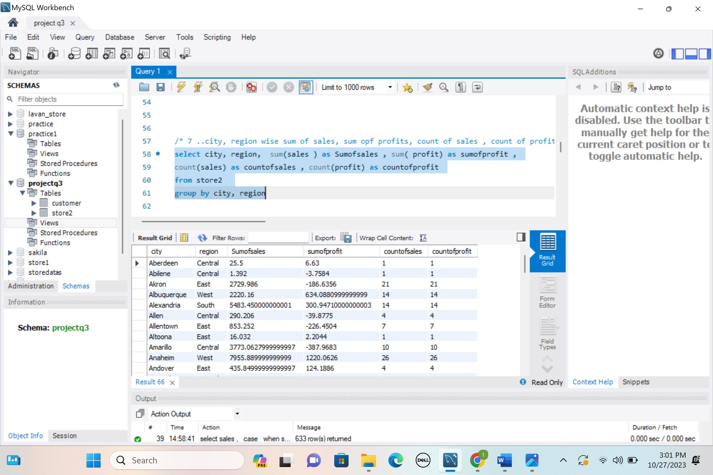

**8.Select all the records belongs to region east & west with sales > 500**

**Query:**

select * from store2

where region in ('East' ,'West') and sales> 500

Output:

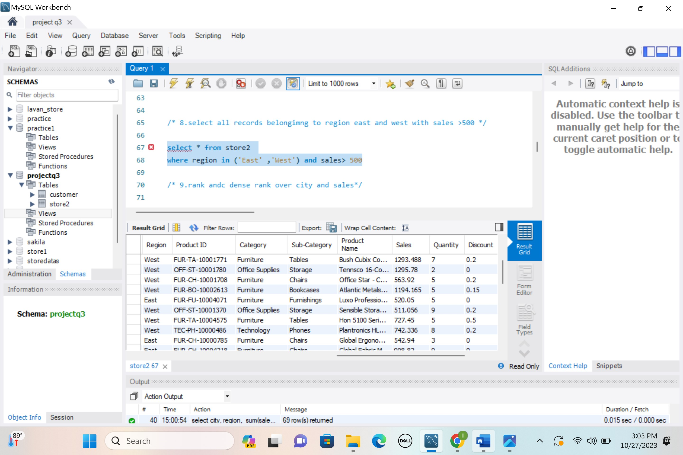

**9.Create rank , dense rank by city and sales**

**Query: - City**

select city,

rank() over( order by city ) as myrank ,

dense_rank() over( order by city ) as myd

from store2

**Output:**

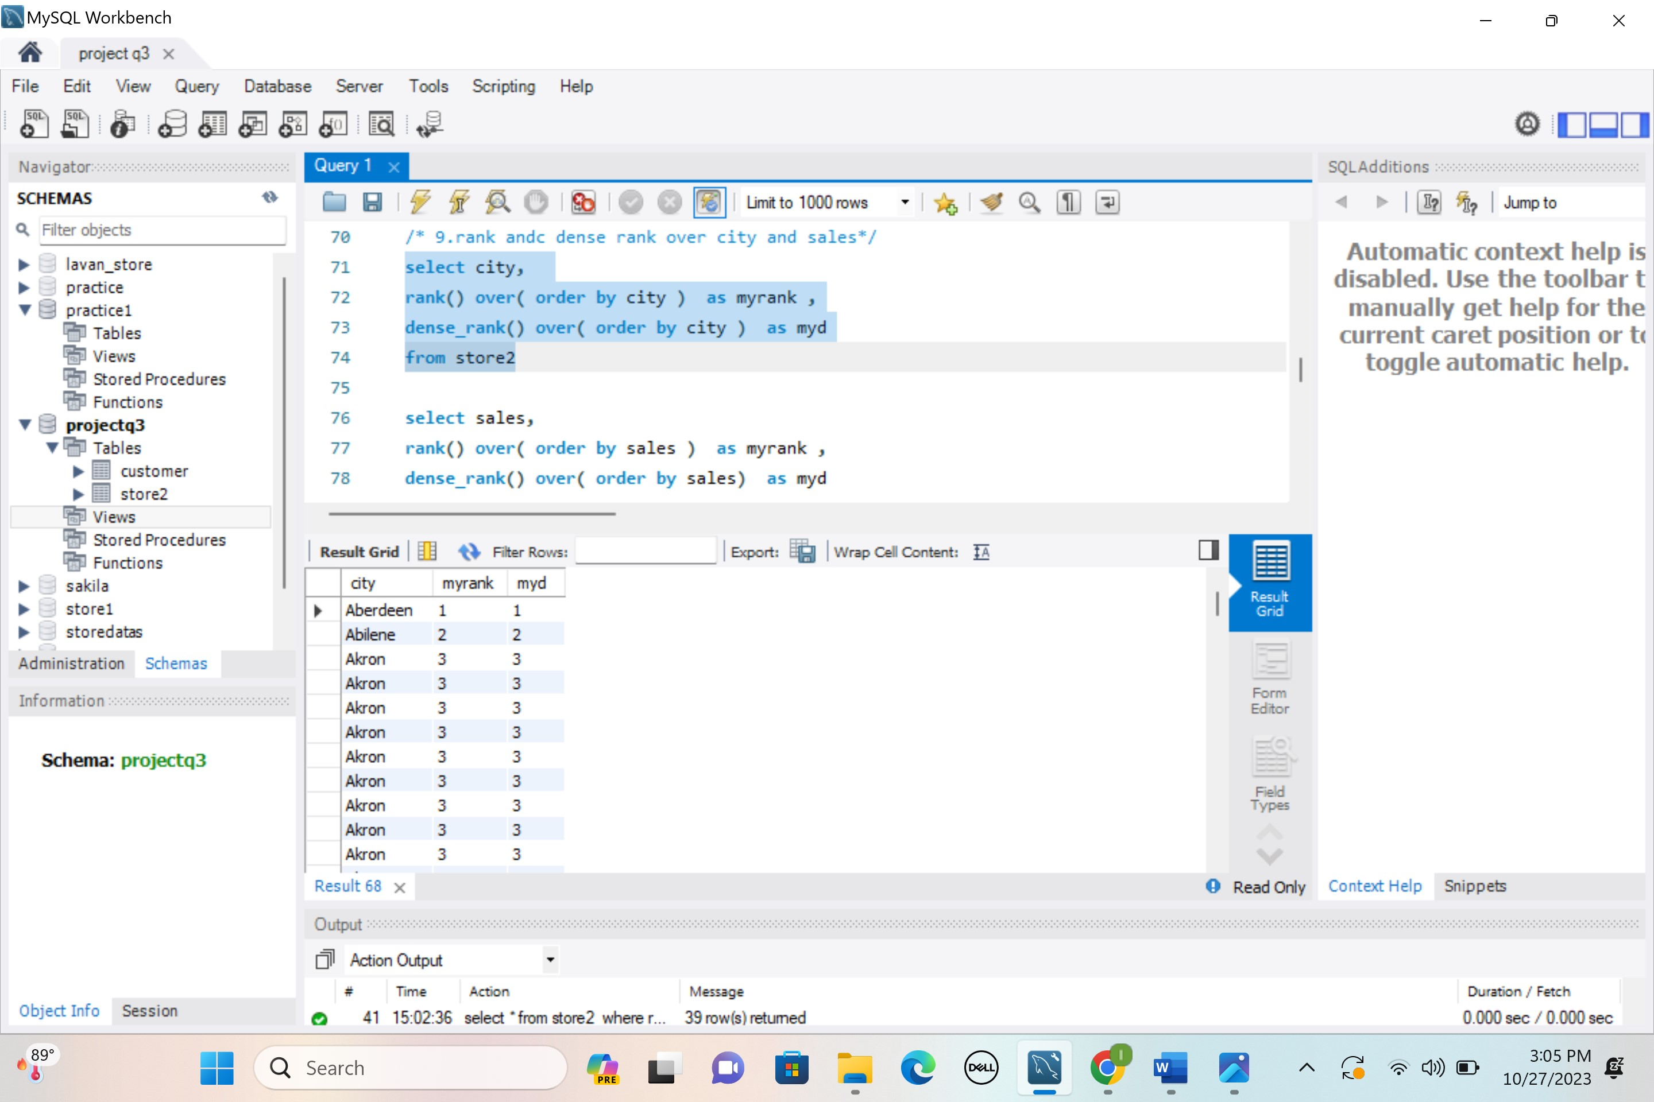

**Query: - Sales**

select sales,

rank() over( order by sales ) as myrank ,

dense_rank() over( order by sales) as myd

**Output:**

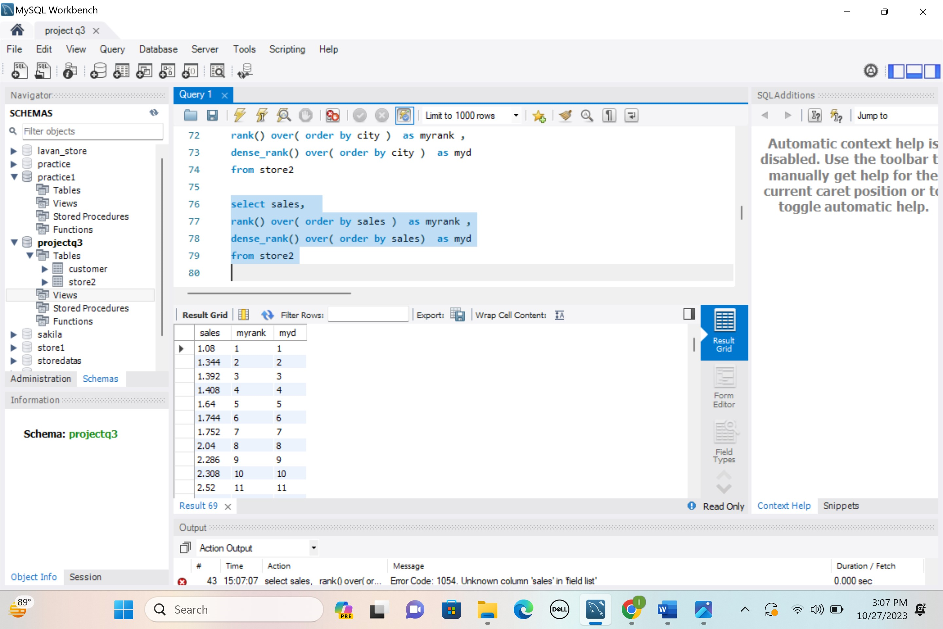

**Query- sales and city together**

select city, sales,

rank() over(partition by city order by sales asc ) as myrank,

dense_rank() over(partition by city order by sales asc ) as mydenserank

from store2

**Output:**

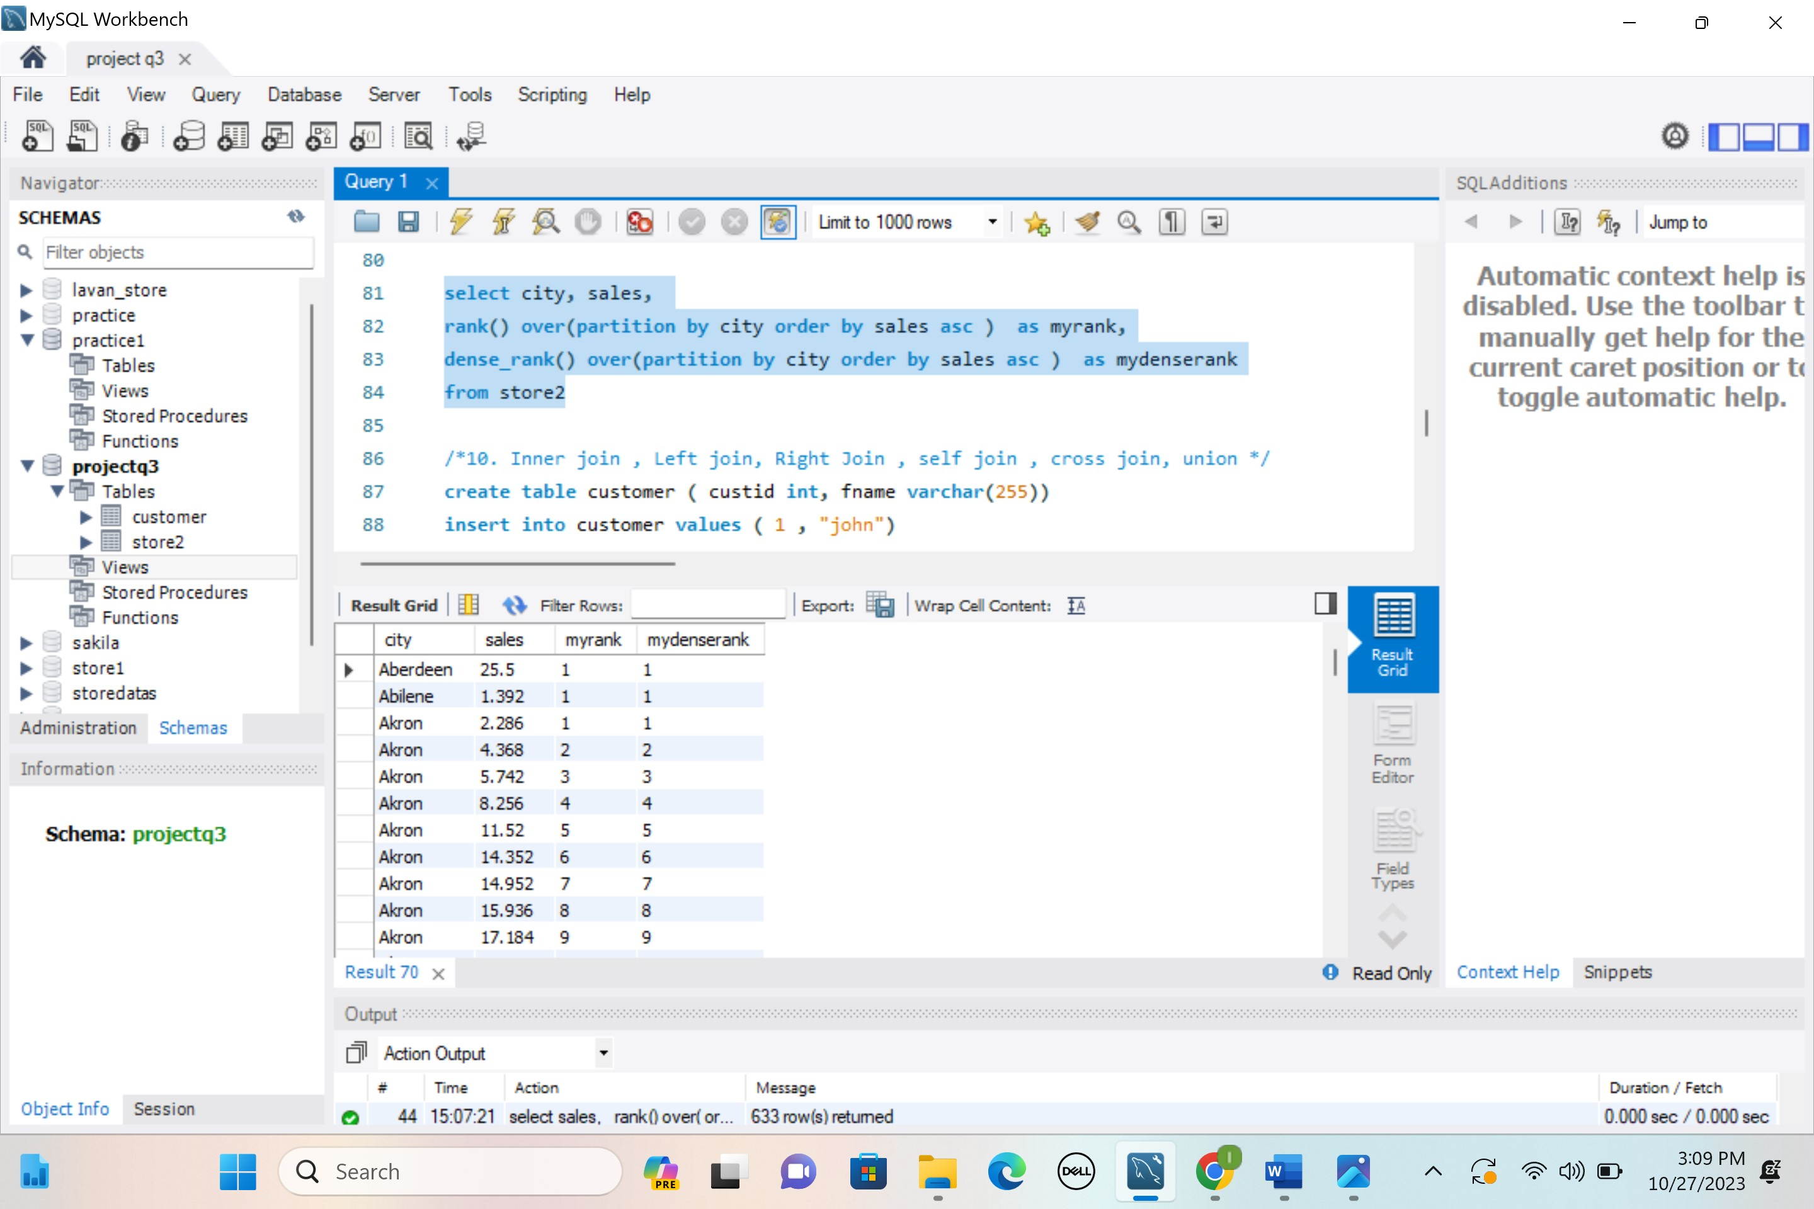

**10. describe about left , right , inner , self , cross joins & unions , subquries**

**1.Left Join :**

It returns all records from the left table (table1), and the matching records from the right table (table2). The result is 0 records from the right side, if there is no match.

**Syntax:**

SELECT column_name(s)  
FROM table1  
LEFT JOIN table2ON table1.column_name = table2.column_name;

**2.Right Join:**

It returns all records from the right table (table2), and the matching records from the left table (table1). The result is 0 records from the left side, if there is no match.

**Syntax:**

SELECT column_name(s)  
FROM table1  
RIGHT JOIN table2ON table1.column_name = table2.column_name;

**3.Inner Join:**

It selects records that have matching values in both tables.

**Syntax:**

SELECT column_name(s)  
FROM table1  
INNER JOIN table2ON table1.column_name = table2.column_name;

**4.Self Join:**

In SELF JOIN a table is joined to itself. That is, each row of the table is joined with itself and all other rows.  It is useful when a user wants to compare the data (rows) within the same table.In other words we can say that it is a join between two copies of the same table.

**Syntax:**

SELECT column_name(s)  
FROM table1 T1, table1 T2  
WHERE condition;

T1 and T2 are different aliases name of same table.

**5.Cross Join or Cartesian Join:**

In a CARTESIAN JOIN there is a join for each row of one table to every row of another table. This usually happens when the matching column or WHERE condition is not specified.

In the absence of a WHERE condition the CARTESIAN JOIN will behave like a CARTESIAN PRODUCT. i.e., the number of rows in the result-set is the product of the number of rows of the two tables.

In the presence of WHERE condition this JOIN will function like a INNER JOIN.

Generally speaking, Cross join is similar to an inner join where the join-condition will always evaluate to True.

**Syntax:**

SELECT table1.column1, table1.column2, table2.column1...

FROM table1

CROSS JOIN table2;

**table1**: First table

**table2**: Second table

**6.Union:**The UNION operator is used to combine the result-set of two or more SELECT statements. Every SELECT statement within Union must have the same number of columns. The columns must also have similar data types and the columns in every SELECT statement must also be in the same order.

**Syntax:**SELECT column_name(s) FROM table1  
UNION  
SELECT column_name(s) FROM table2.

**7.Subqueries:**A Subquery can be simply defined as a query within another query. In other words we can say that a Subquery is a query that is embedded in WHERE clause of another SQL query. The Subquery can be placed in a number of SQL clauses: [WHERE](https://www.geeksforgeeks.org/sql-where-clause/) clause,[HAVING](https://www.geeksforgeeks.org/having-vs-where-clause/) clause, FROM clause. Subqueries can be used with SELECT, UPDATE, INSERT, DELETE statements along with expression operator. It could be equality operator or comparison operator such as =, >, =, <= and Like operator.

**Syntax:**

SELECT column_name

FROM table_name

WHERE column_name *expression operator*

( SELECT COLUMN_NAME from TABLE_NAME WHERE ... );

**Queries for all join:**

create table customer ( custid int, fname varchar(255))

insert into customer values ( 1 , "john")

insert into customer values ( 2 , "robert")

insert into customer values ( 3 , "david")

insert into customer values ( 4 , "john")

insert into customer values ( 5 , "betty")

create table order1 (orderid int , amount int, custid int)

insert into order1 values ( 1,200,10)

insert into order1 values ( 2,500,3)

insert into order1 values ( 3,300,6)

insert into order1 values ( 4,800,5)

insert into order1 values ( 5,150,8)

select * from customer

select * from order1

**/*inner join */**

select fname , amount, customer.custid

from customer

inner join order1 on customer.custid=order1.custid

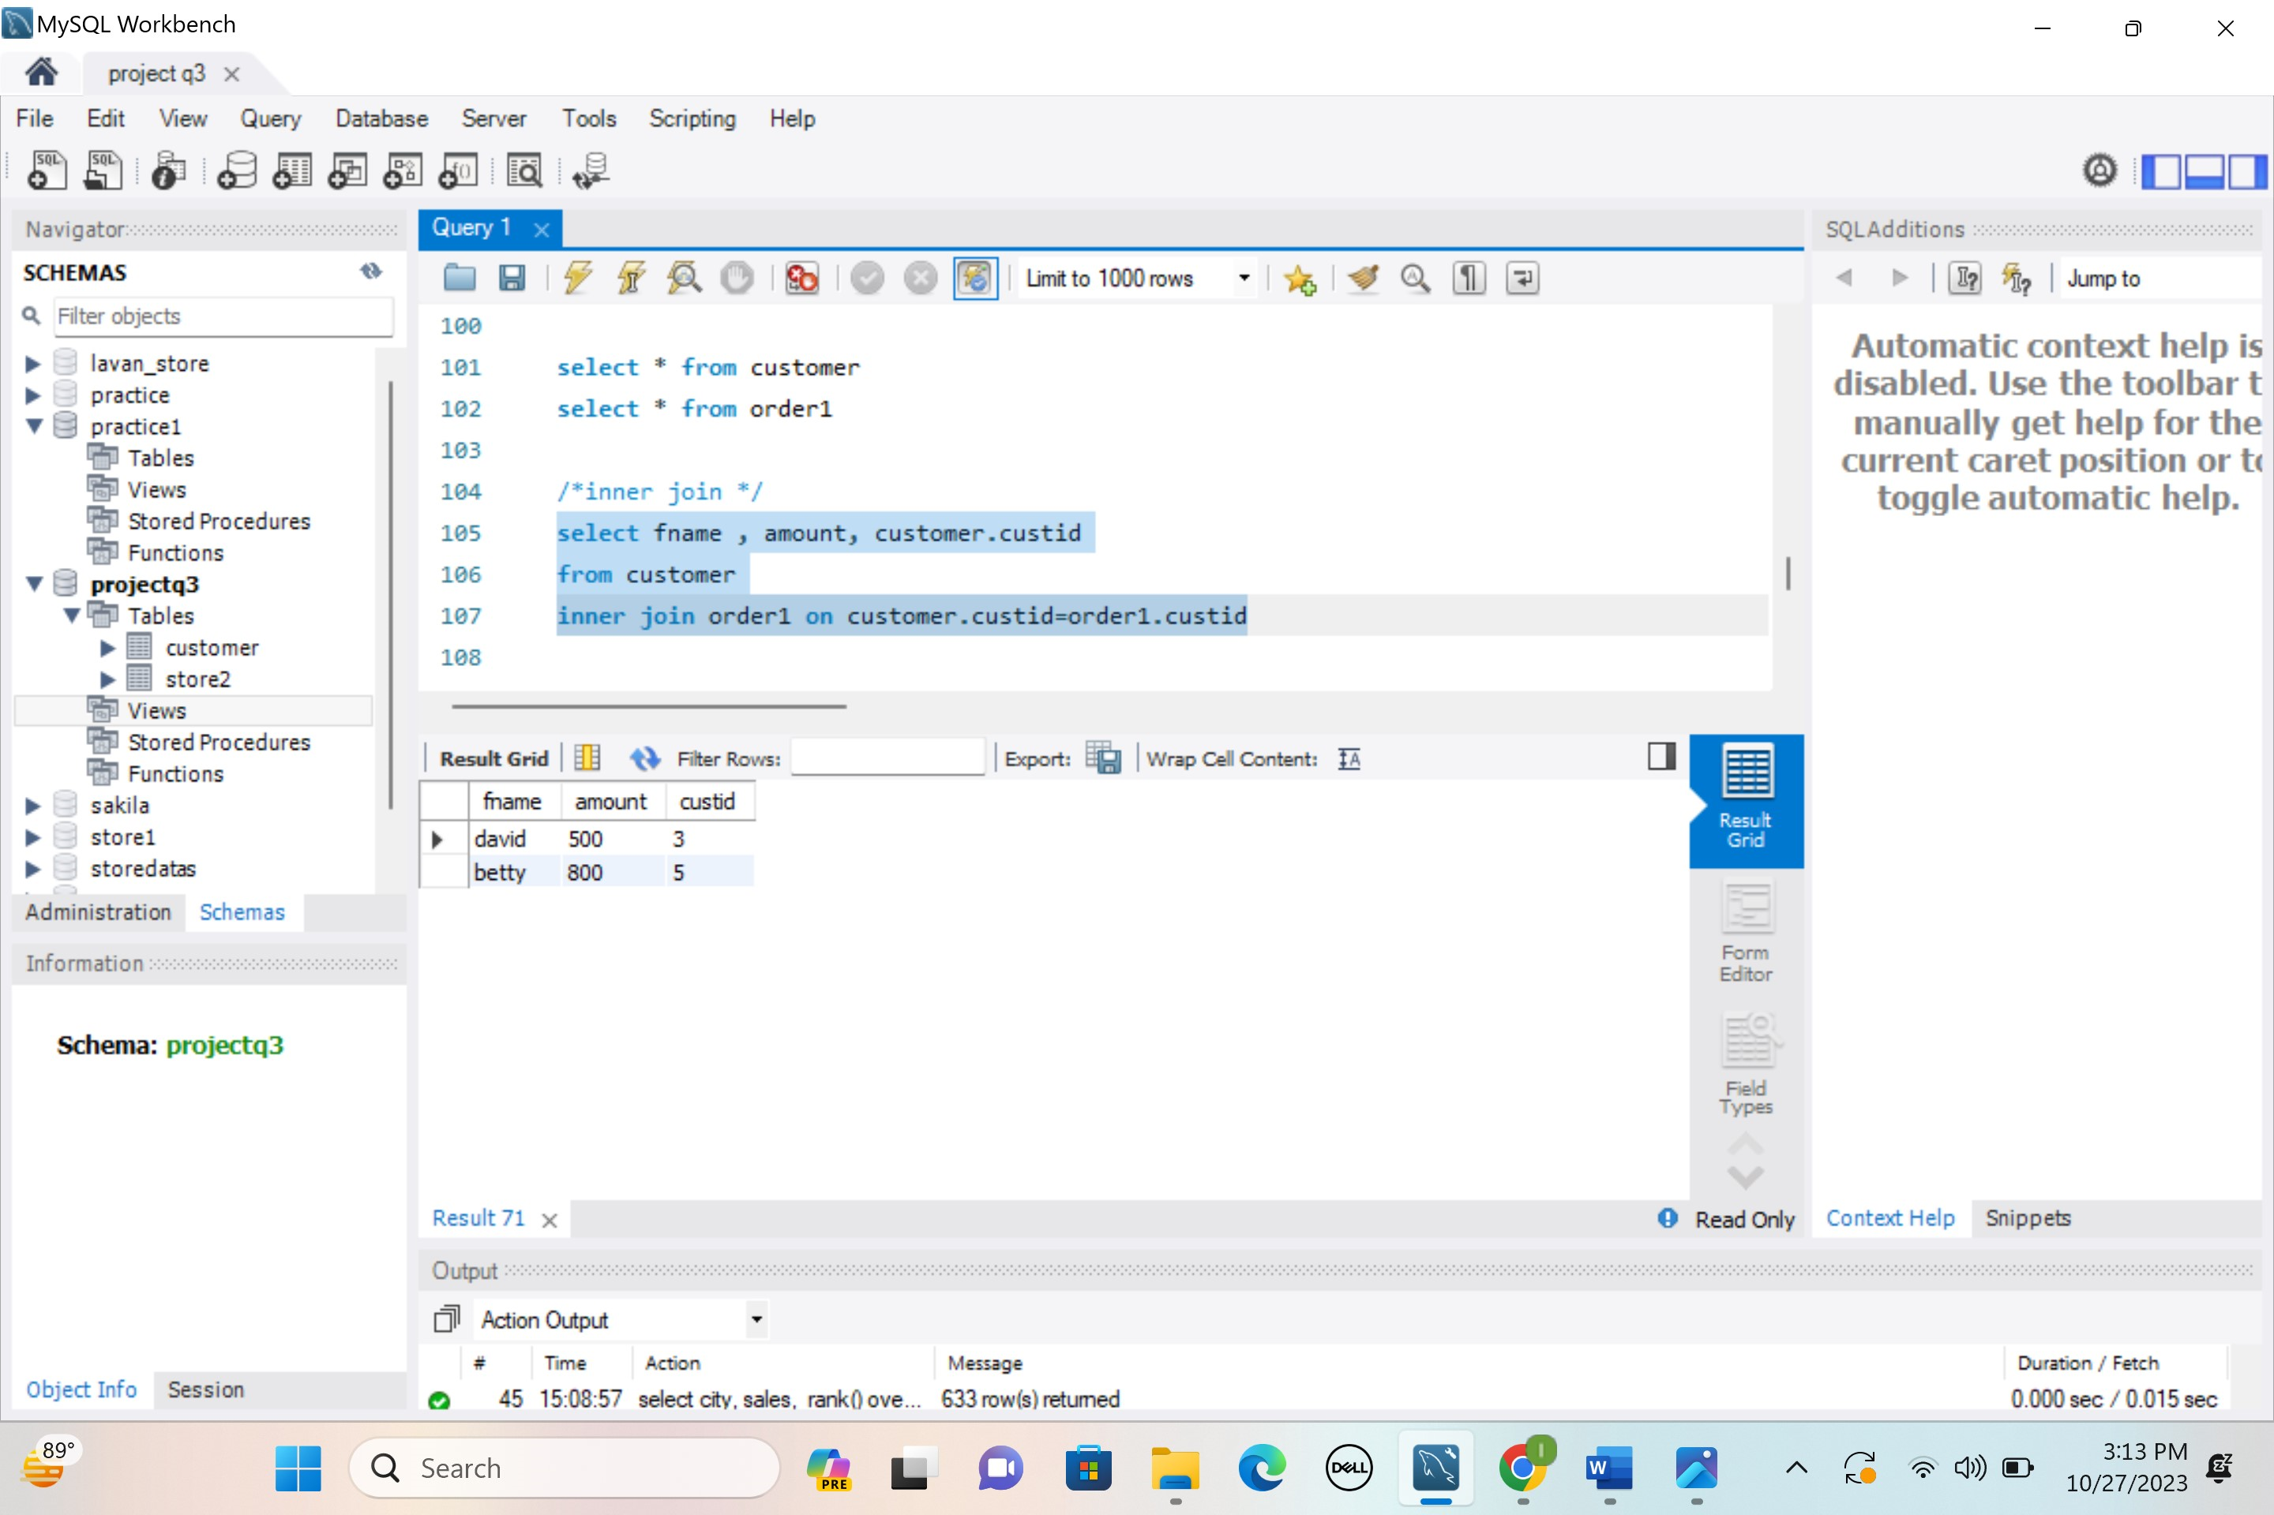

**/*left join */**

select fname , amount, customer.custid

from customer

left join order1 on customer.custid=order1.custid

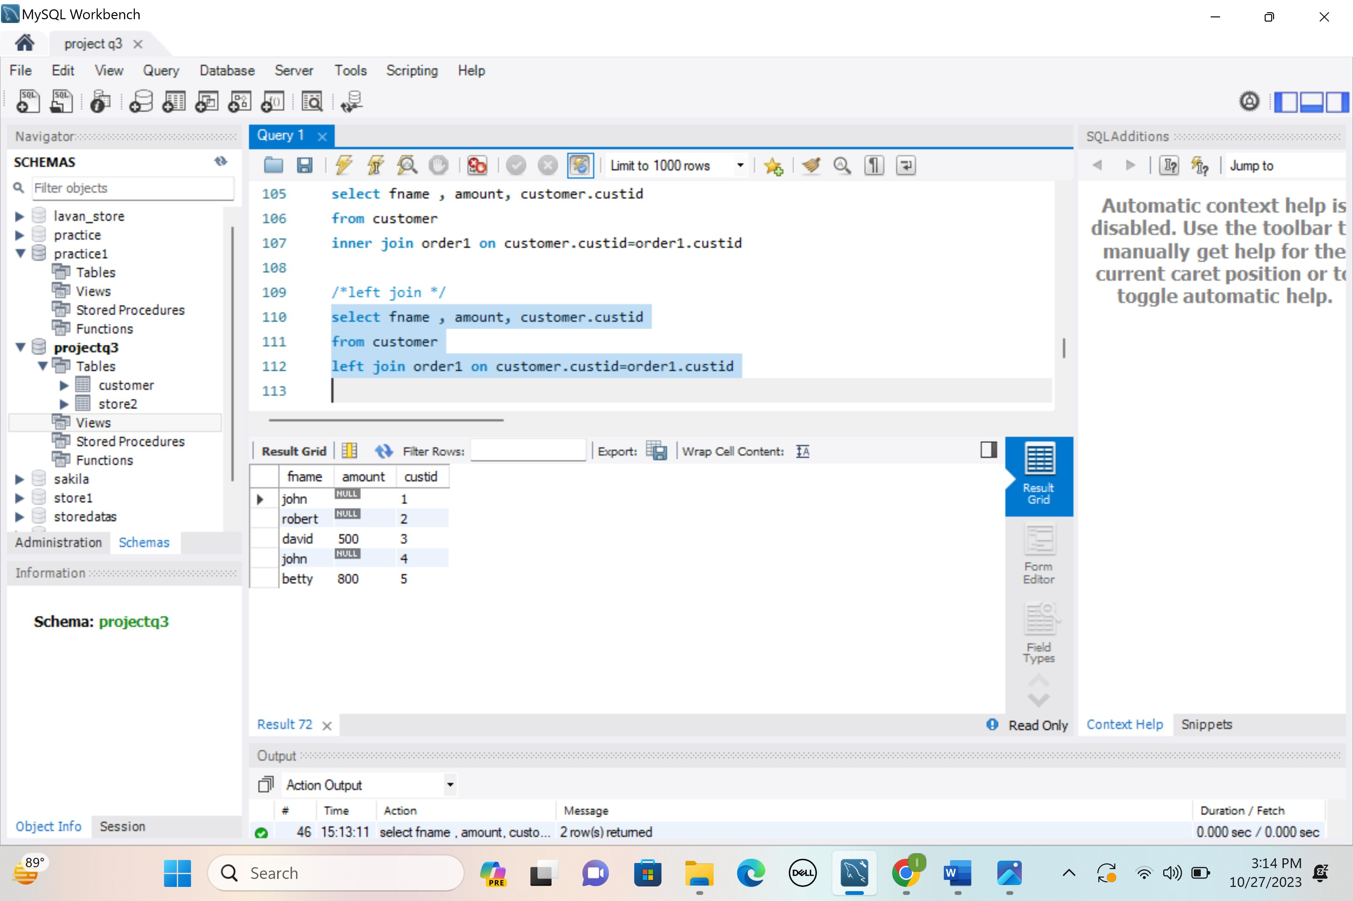

**/*right join */**

select fname , amount, customer.custid

from customer

right join order1 on customer.custid=order1.custid

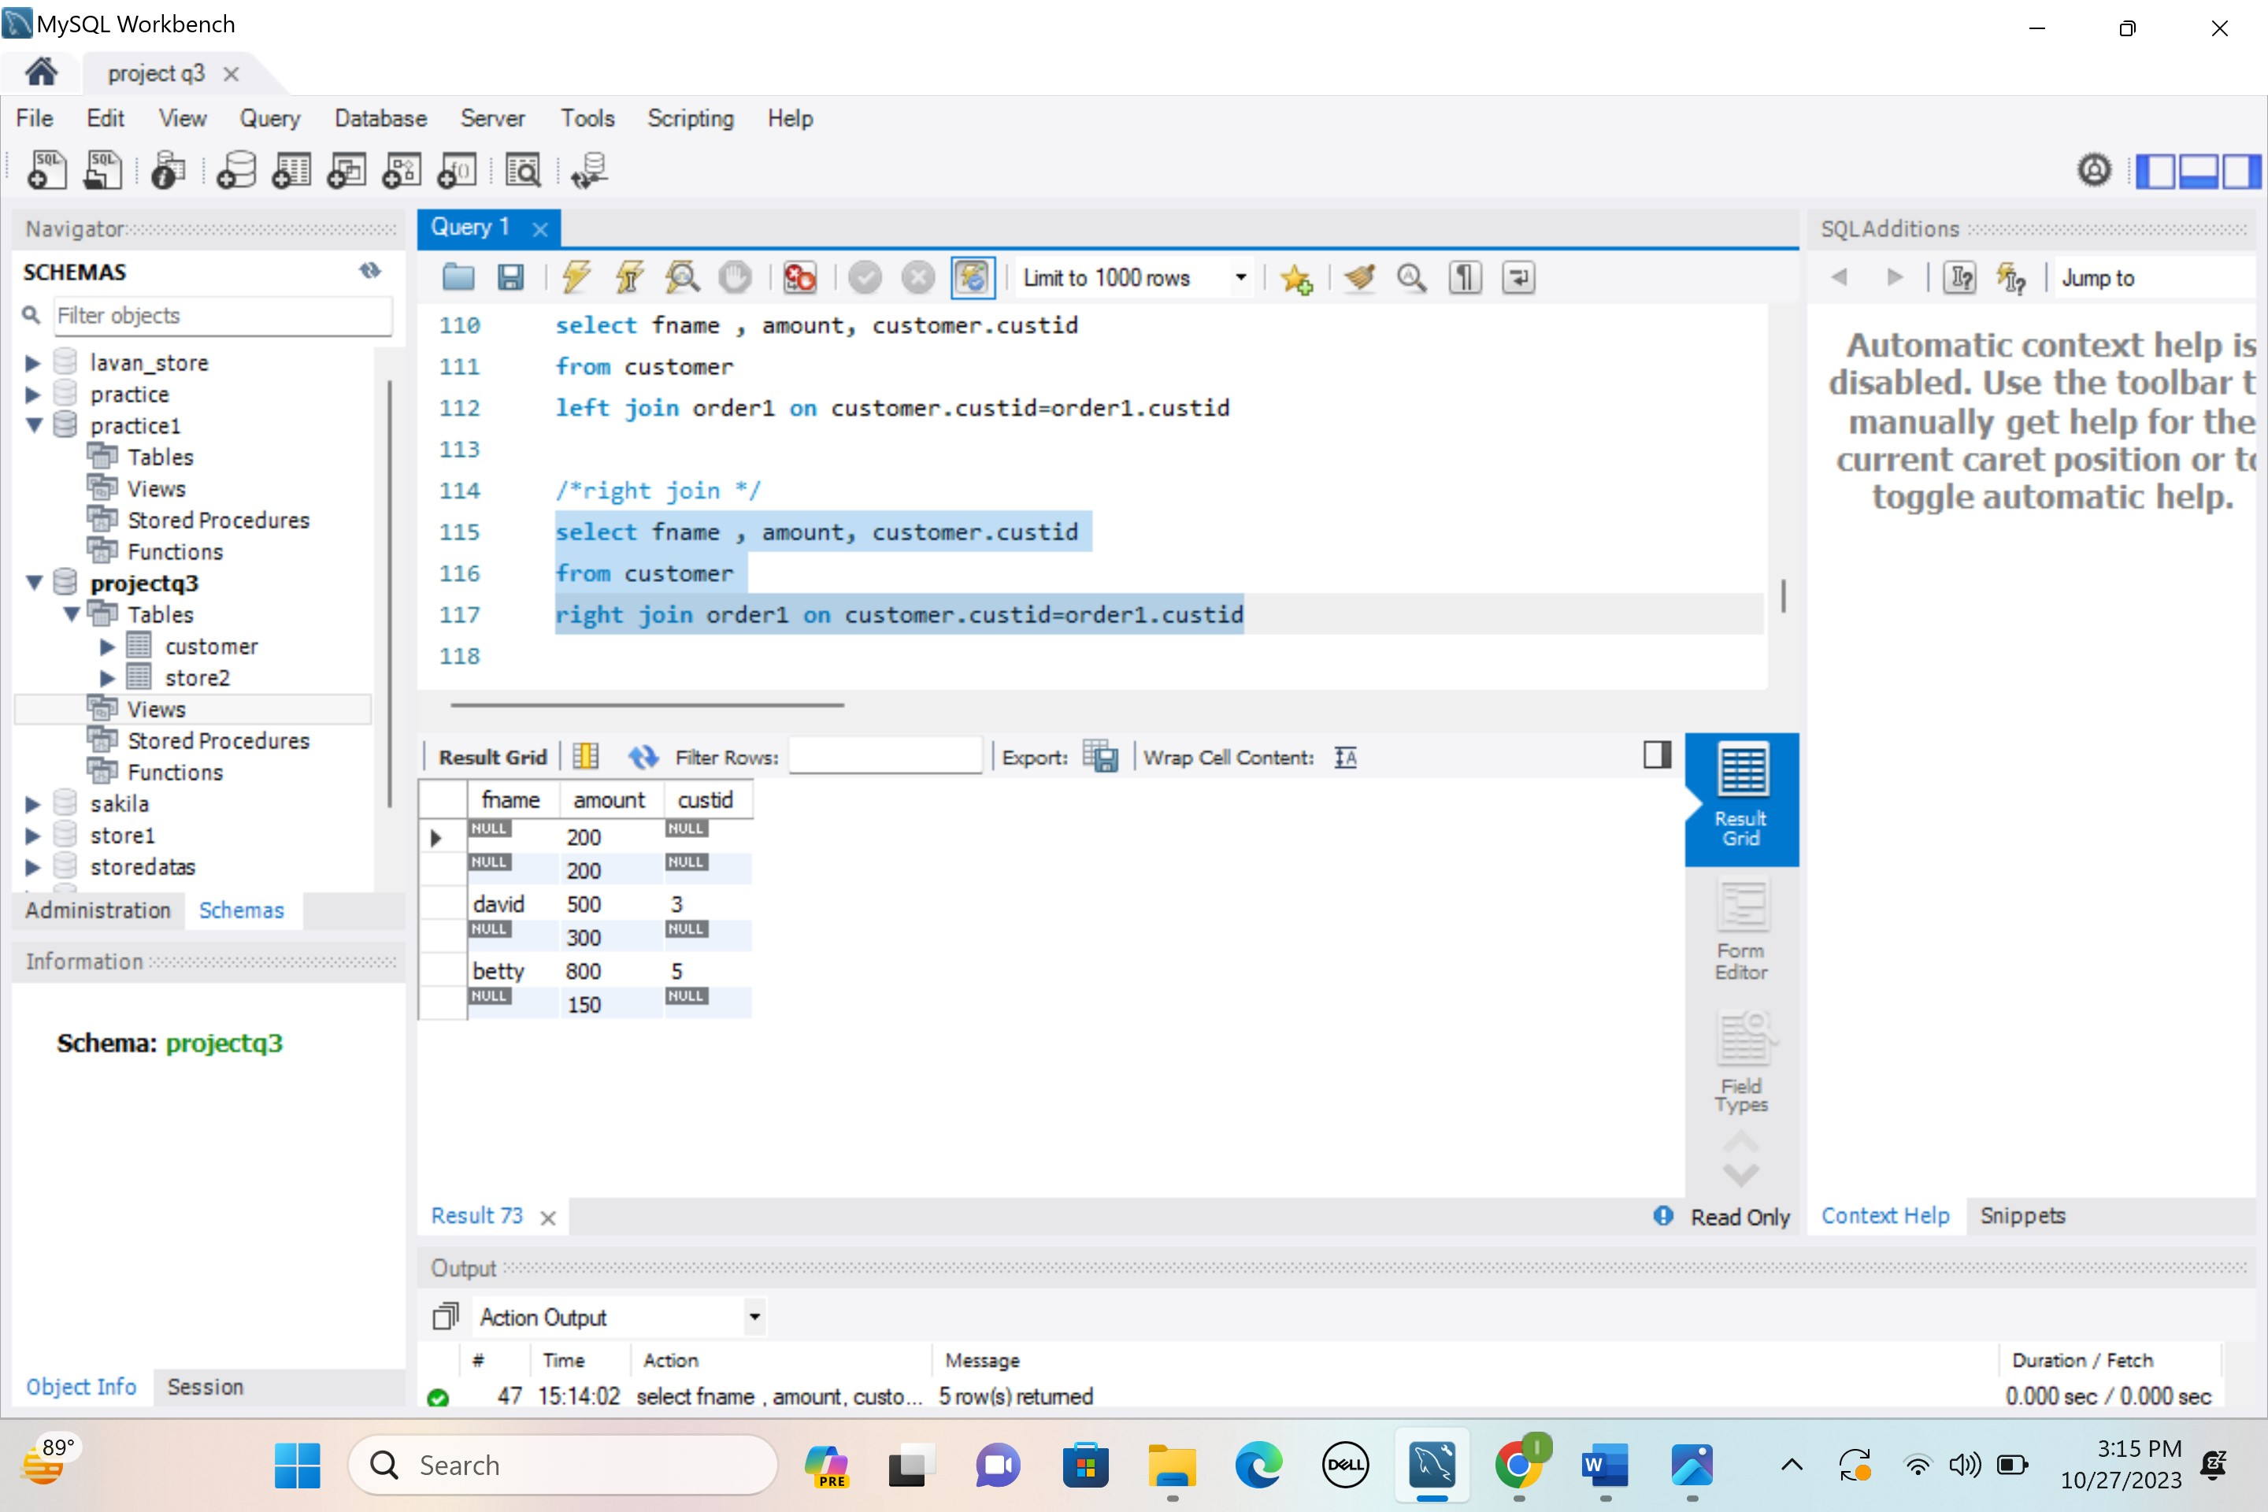

**/* self join*/**

SELECT fname, amount

FROM customer T1, order1 T2

WHERE amount > 200;

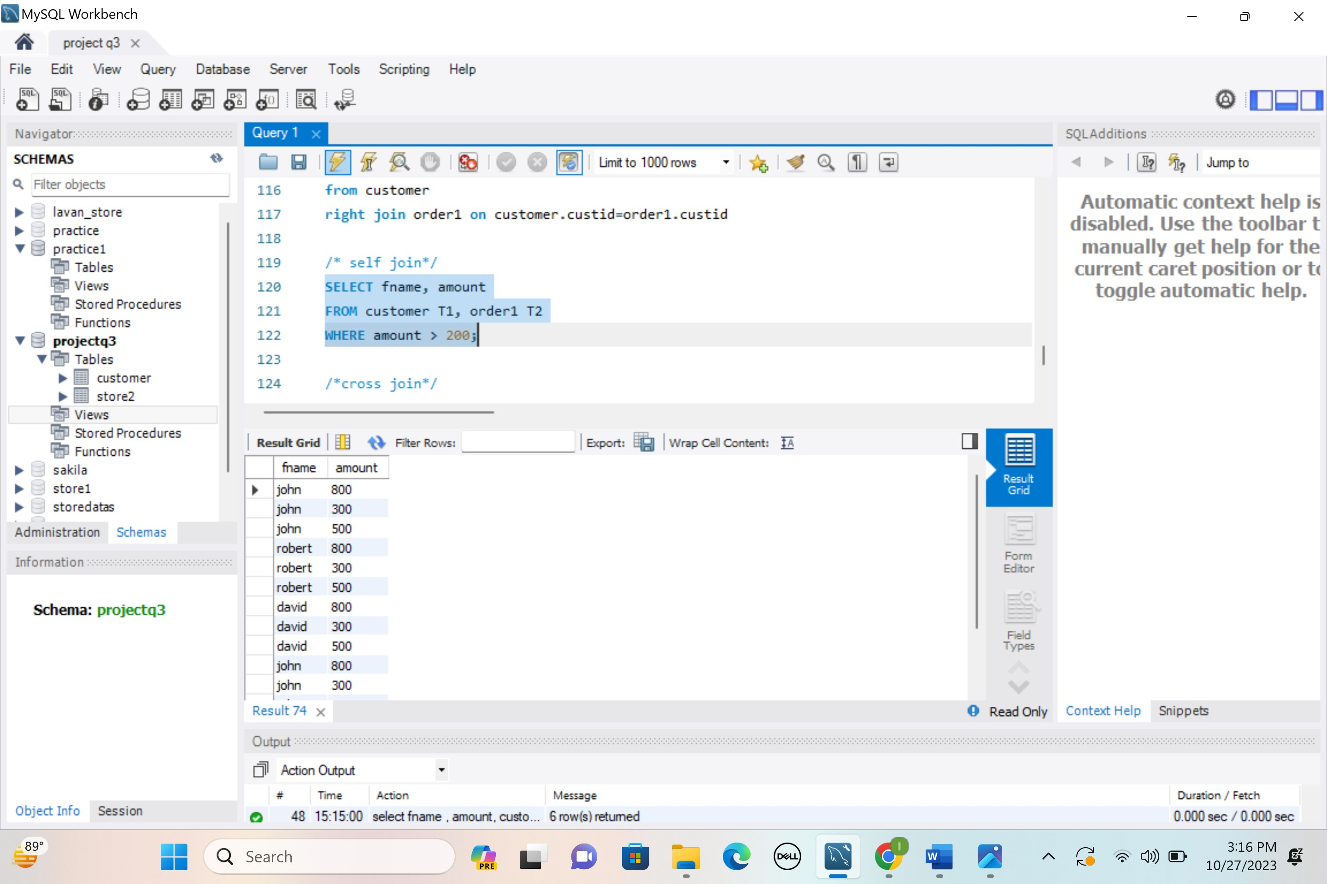

**/*cross join*/**

SELECT customer.custid, customer.fname, order1.amount

FROM customer

CROSS JOIN order1;

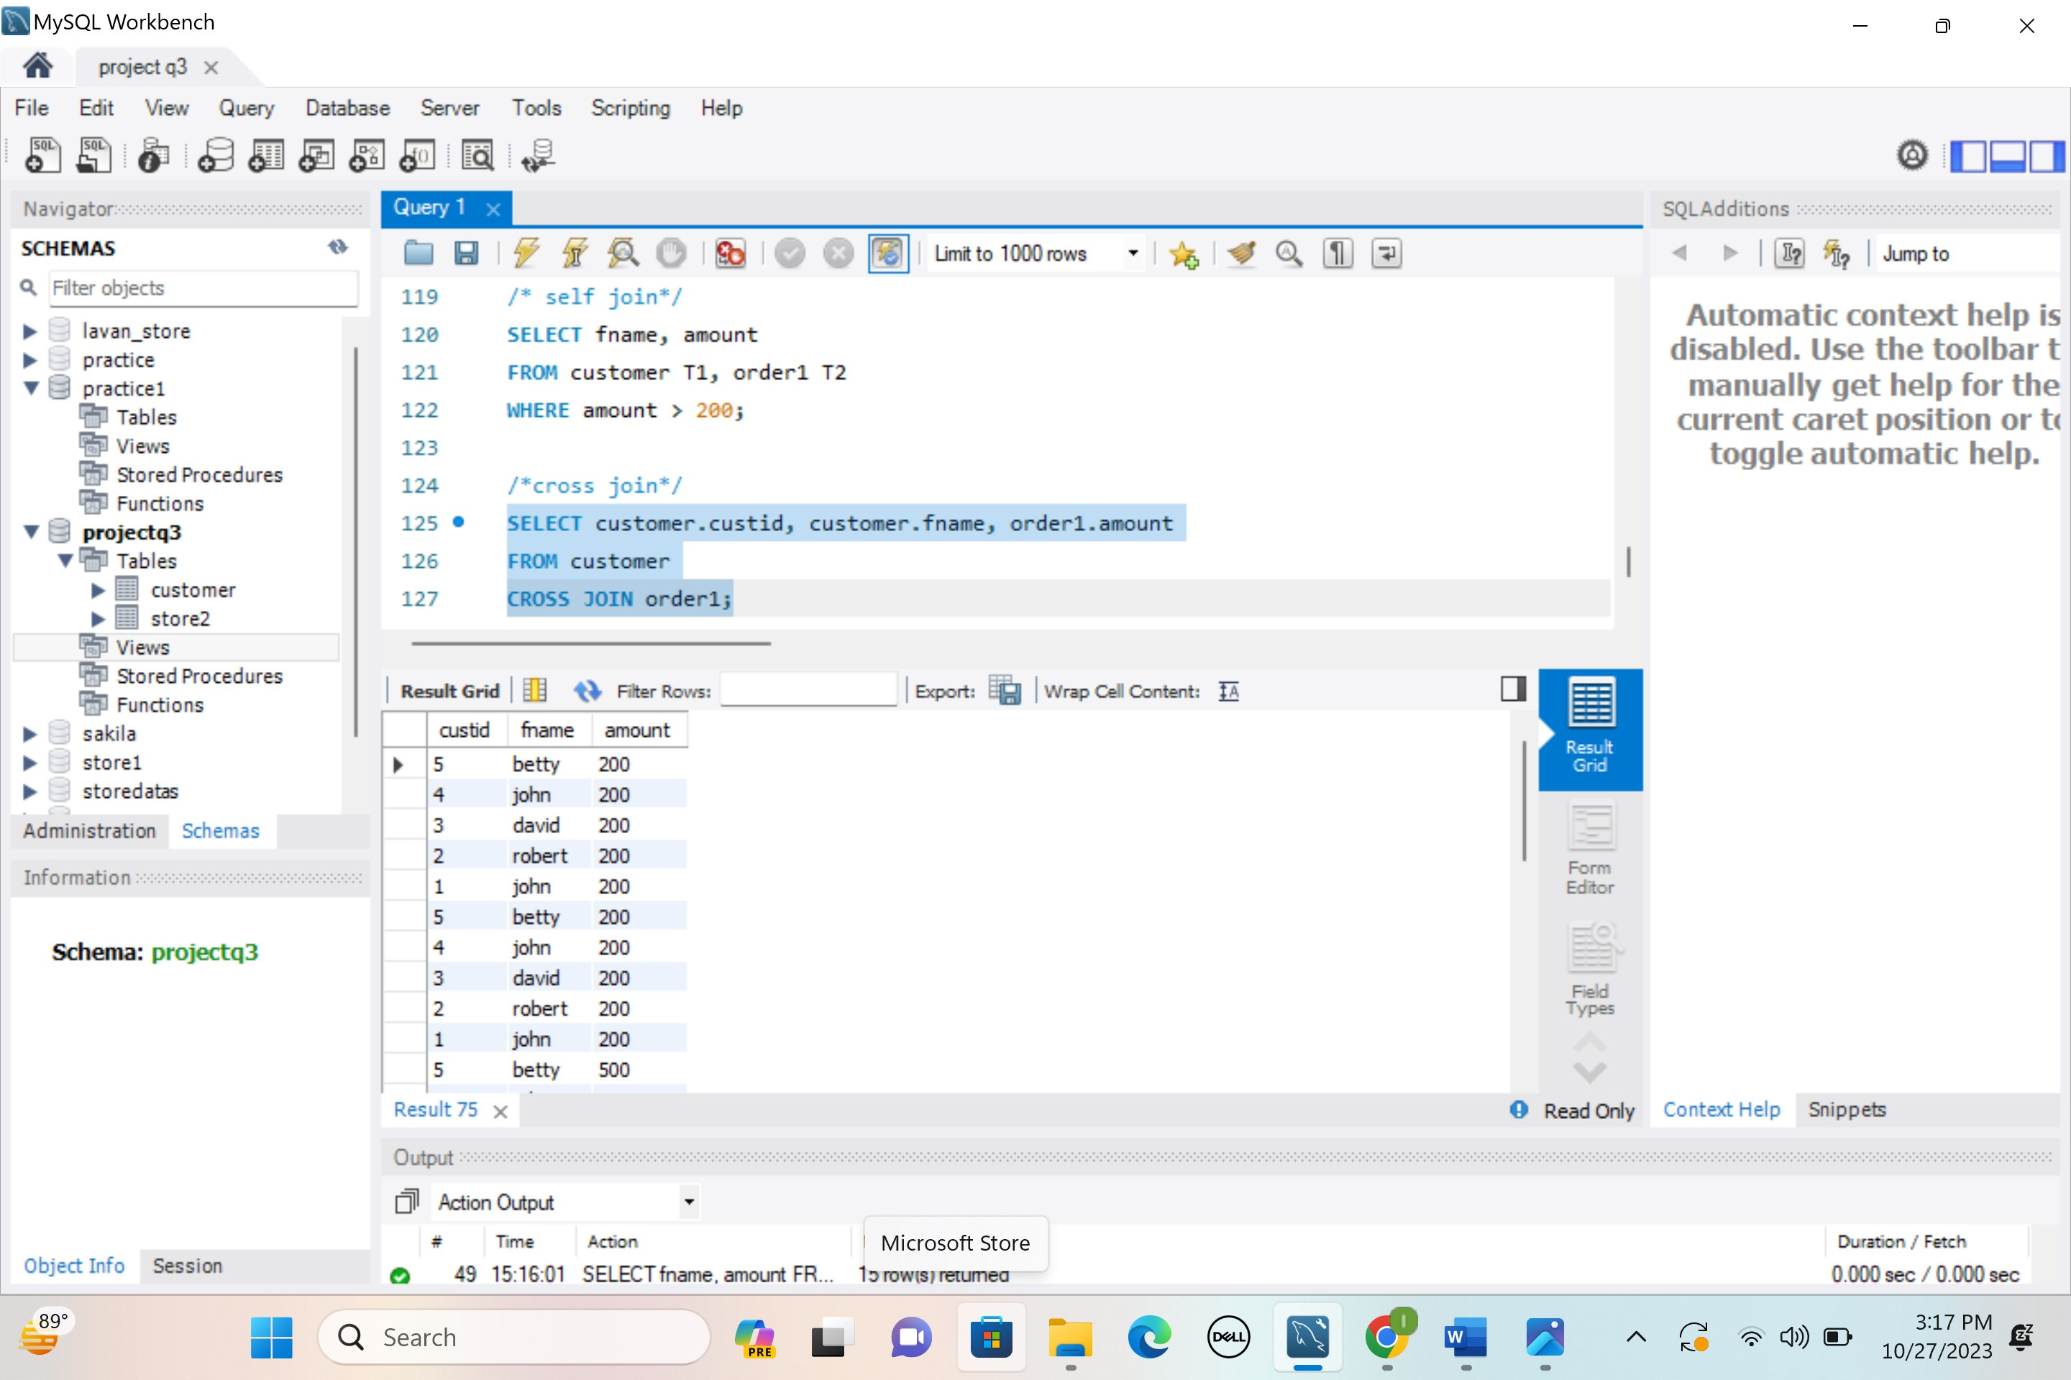

**/* union*/**

SELECT custid FROM customer

UNION

SELECT custid FROM order1

